

Widgets

INSTALLATION GUIDE
for Openpay Popup info Widgets Extension for Magento 1

Step 1 :
Go to your projects root folder & then upload files and folder to the root.

If you have any custom theme then upload theme files to the current theme (app/design/frontend/<Your package>/<Your Theme>).

Step 2 :
Then login to magento admin panel: SYSTEM -> Configuration -> OPENPAY WIDGET -> Widget Setup

1. Enable the module :

Expand 'Openpay Widgets Configuration' & set 'Yes' value against 'Enable Widgets' field.

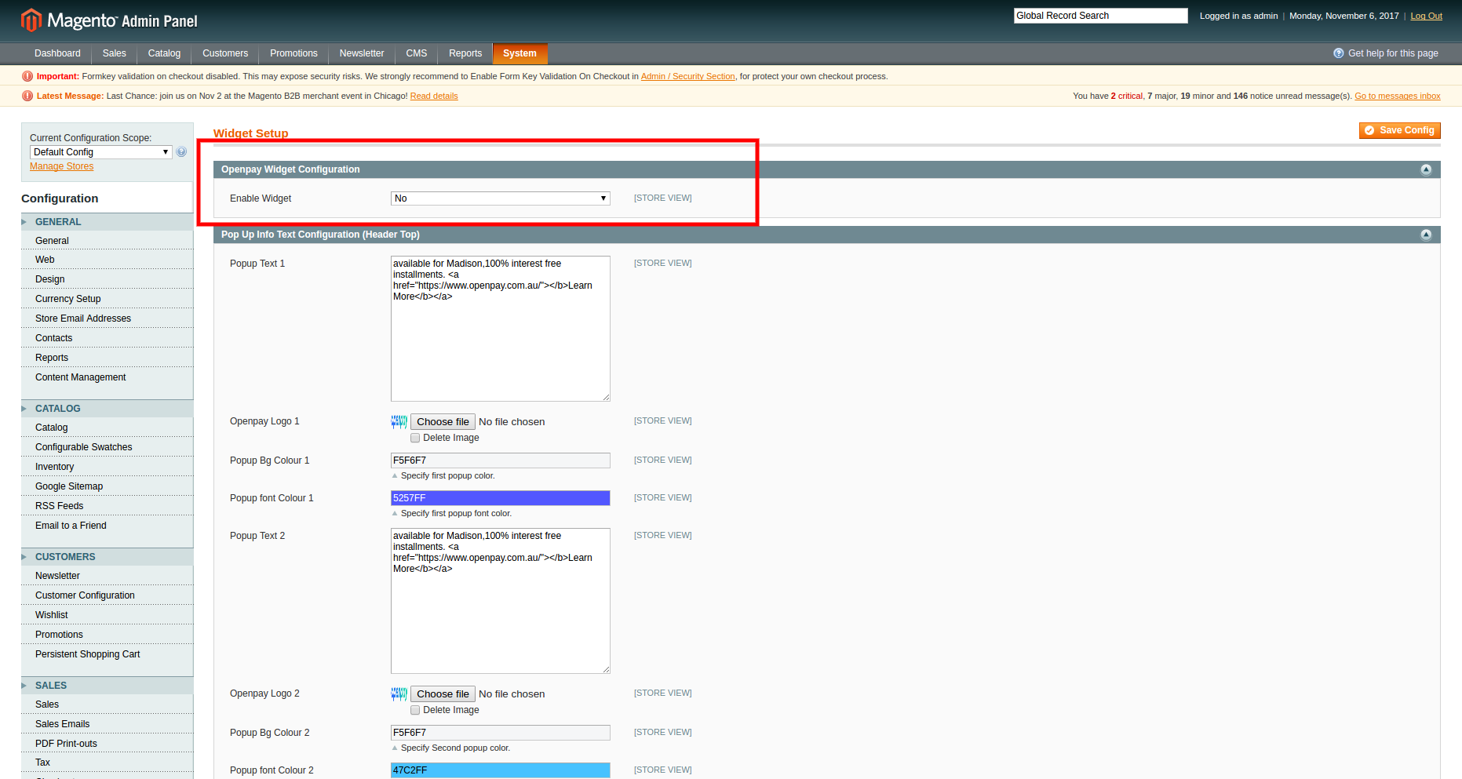

Click on 'Save Config'.

2. Set up 'Pop up info' widget :

Expand 'Pop Up Info Text Configuration (Header Top)' & fill out the fields as required.

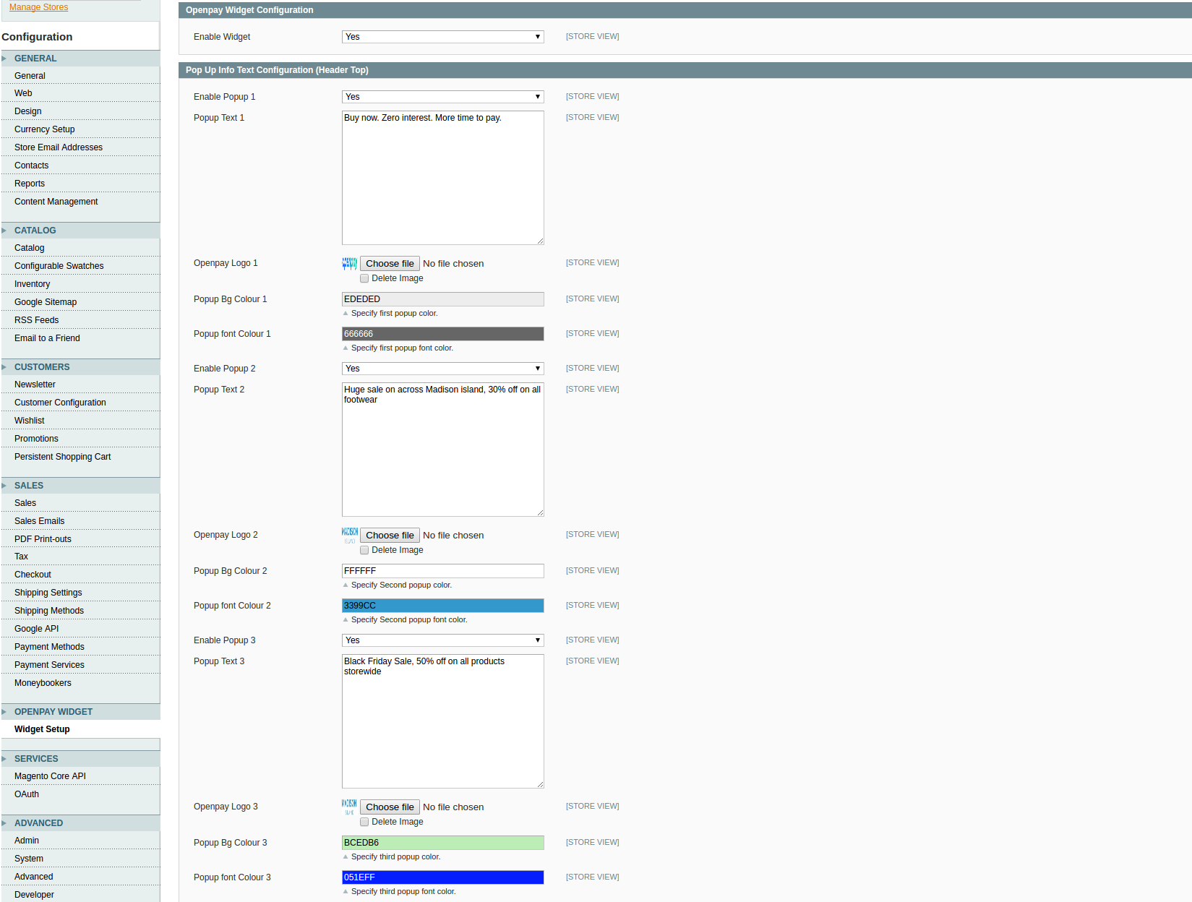

Enable Popup 1 => To enable the 1st popup
Popup Text 1 => This text will be visible in 1st popup
Openpay Logo 1 => Upload logo for 1st popup
Popup Bg Colour 1 => Default Bg Colour “#EDEDED”
Popup font Colour 1 => Default font colour “#666666”

Click on 'Save Config'.

Frontend View :

'Pop up info' widget :

If module is enabled form admin it will aytometically comes in front-end header



